EXP 9: CREATE A VIRTUAL HARD DISK AND ALLOCATE THE STORAGE USING VM WARE WORKSTATION.
AIM: To create a virtual hard disk and allocate the storage using vm ware workstation
PROCEDURE:
step 1: go to vmware workstation.
step2: right click the vm and goto the settings.
step 3: add hardware wizard and select scsi and click next.
step 4: create new virtual disk.
step 5: select the disk size as 2.0. and select split virtual disk into multifiles.
step 6: give name and click the finish.
IMPLEMENTATION:
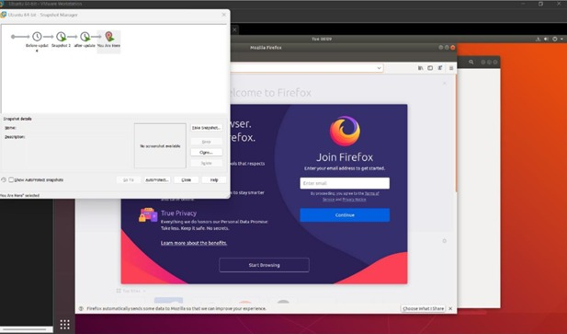
RESULT: thus,it was successfully completed

